**3D REPORT**

Written by: Stefan Beregszaszy

This report will present the effects made for the ACW, in a list:

* **Water effects:**

The effect is realised using a sinus function to calculate the waves through a time variable that changes continuously while multiplied by a frequency variable added by the produce of the Y and Z coordinates of the object which is a flat ocean. The waves are then increased through a magnitude variable and normalized for a seamless procedure.

Fog effects: The effect is realised using a Quad Array and the cosine and sinus functions to determine the x and z coordinates of each quad through the z coordinate of the origin point, multiplied by a variable that acts as the Spread and one as the Height multiplying with Y. The principal is identical to the one of the Fire in which instead of being funnelled out like a fountain or a similar flow of Quads, instead each goes away from the origin immediately and the speed is diminished to almost a halt.

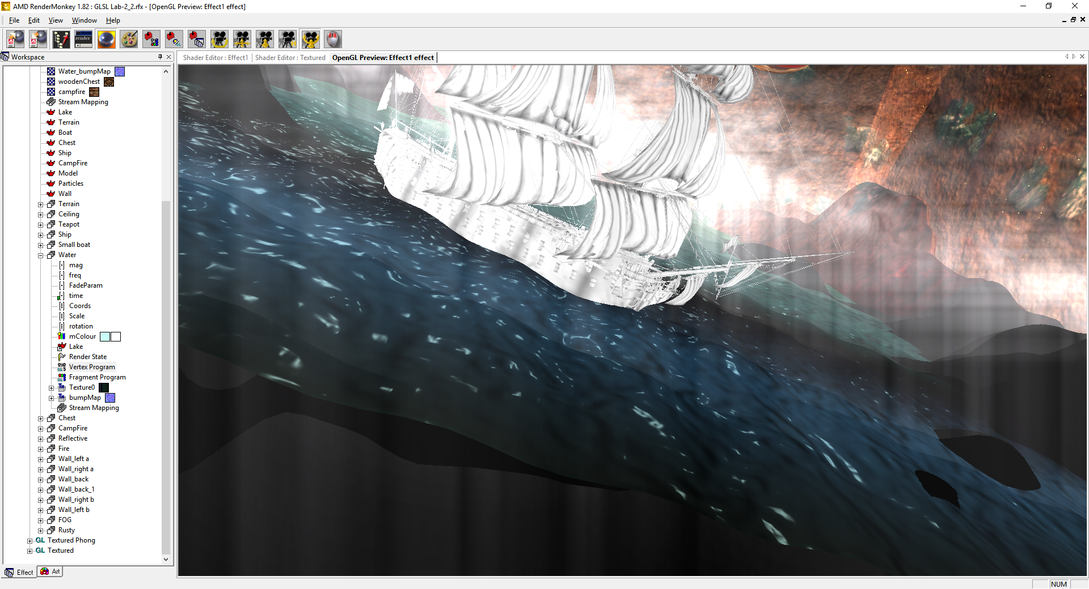

Rusty effect: This effect is realised through scaling, rotating and translating the object to the desired place and loaded in a texture using a 2D texture through a texture object.

* **Fire effects:**

The effect is realised using a sinus function to calculate the waves through a time variable that changes continuously while multiplied by a frequency variable added by the produce of the Y and Z coordinates of the object.

Fog effects: The effect is realised using a Quad Array and the cosine and sinus functions to determine the x and z coordinates of each quad through the z coordinate of the origin point, multiplied by a variable that acts as the Spread and one as the Height multiplying with Y. The principal is identical to the one of the Water, in which instead of being spread out like a fountain or a similar flow of Quads, instead each goes out from the origin immediately and the speed is increased to go through the flow of colour.

* **Lighting:**

This effect is realised through using the View and Light position to calculate the Normal and using the Height and bump maps will determine effectively the shadow/ contrast of the object through Ambient/Specular/Diffuse. The Normal will be a measure for the vector of View to get the correct results of light/contrast to the Object.

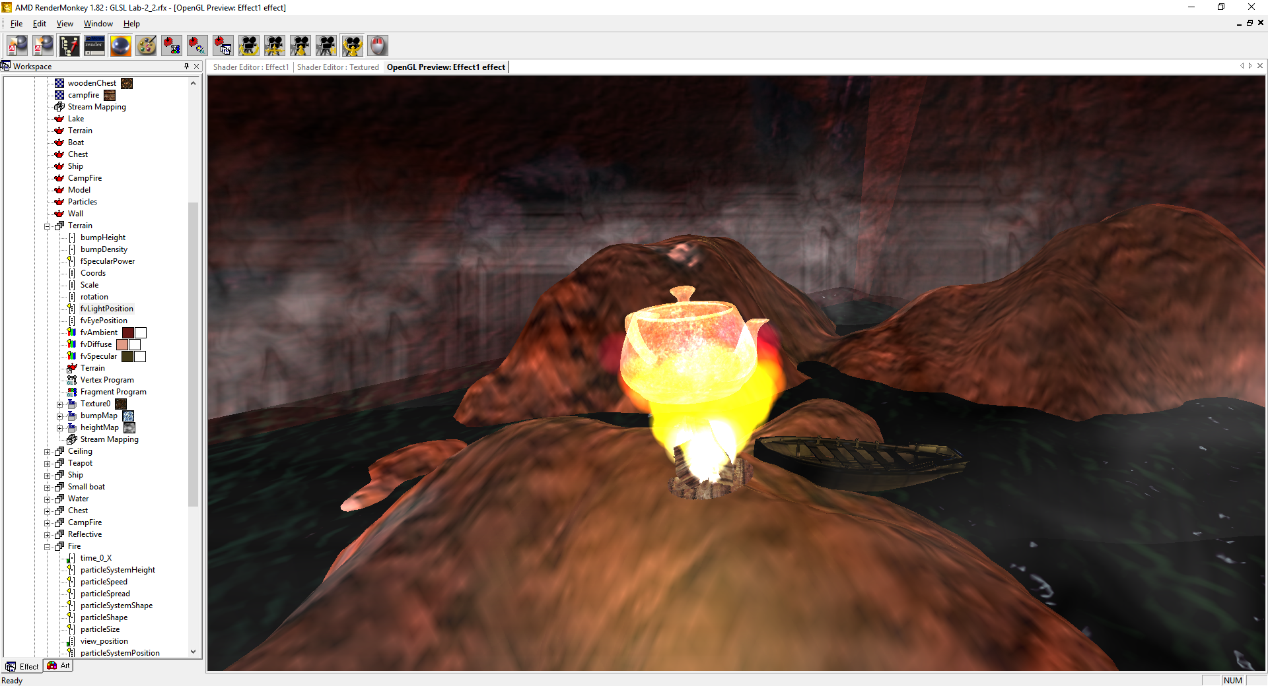

Bump and height mapping: Loading the Normal and height maps, along with the base map, the terrain object is now containing the peek points and vertices of the ridges and he texturing that can be used for Parallax texturing. Through the use of height and bump maps, the lighting system can be used correctly and will give a precision to the light vector. The height values are taken and used to determine the height of the map and it’s vertices for the bump mapping.

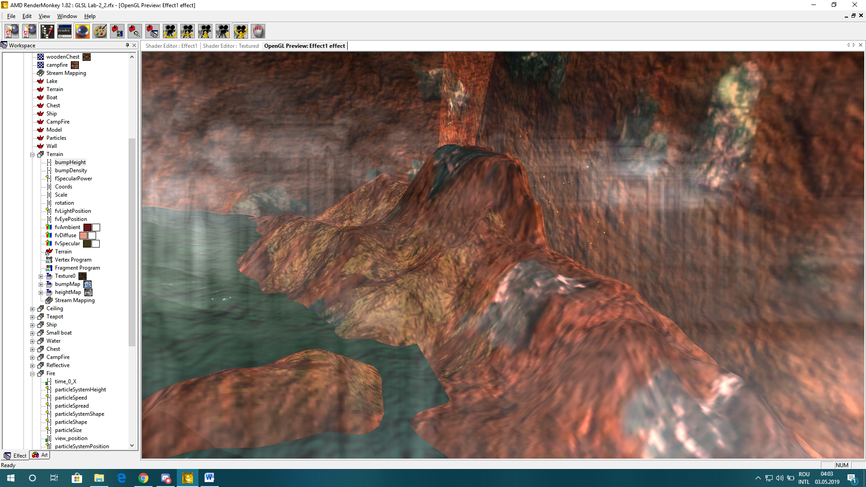

* **Reflective effect:**

This effect is used through the use of cube maps that once loaded to the viewDirection and stopped from being interfered in the reflection by other objects; the mode will curb and perfectly reflect the environment presented by the cube map which is given as the only source of the world between itself and the model.

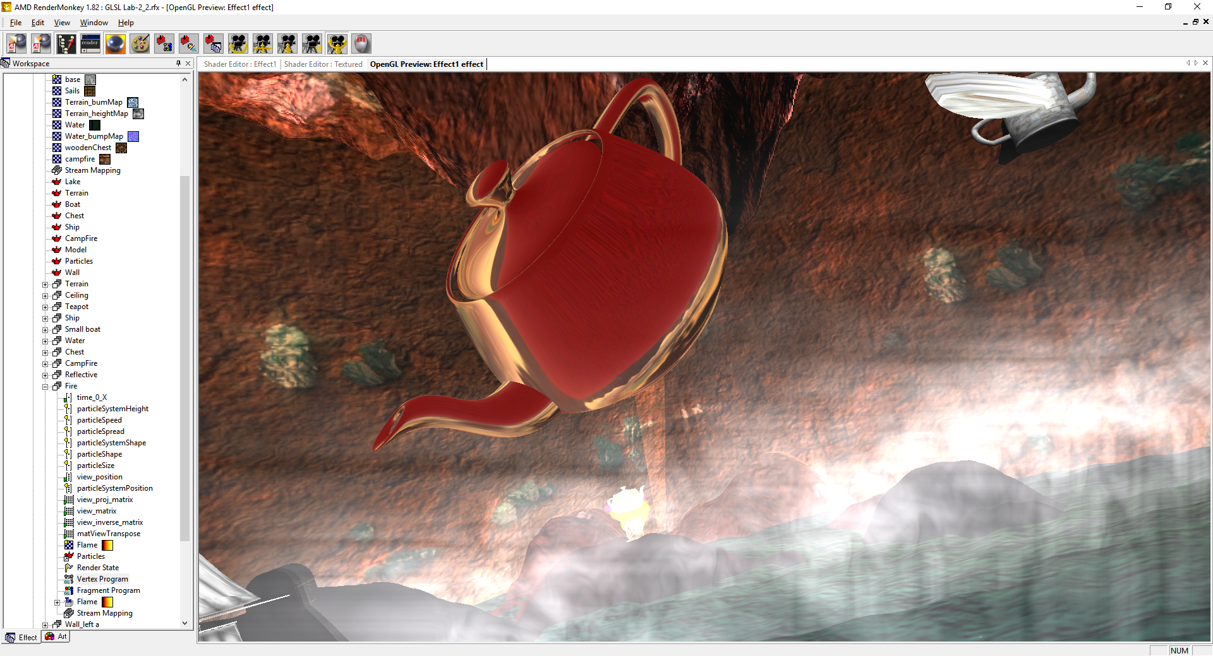

* **Textured chest:**

This effect is realised through scaling, rotating and translating the object to the desired place and loaded in a texture using a 2D texture through a texture object. Loaded a model and got the position of the Object through the Vertex

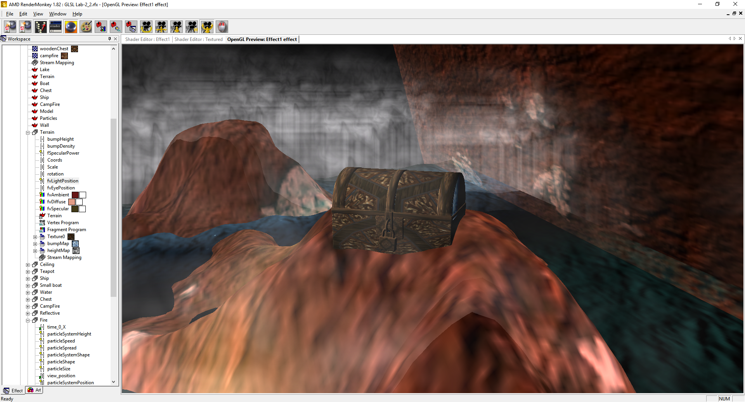

* **Deformation and smoothTexture:**

Using localised transformations and smoothing intervals at an Angle, the selected areas of the Object will be deormed into wings based on the magnitude value given. After which through the use of rotation matrixes for the Z and X axis to make the wings fly. Texture applied and selected parts of the bject to relocate/ Resize,using if statements for intervals of values for the X ad Y coordinates.